CONSOLE MOUNTED GRAPH MEASUREMENTS
WE HAVE THE WINDSHIELD CORNER LOCATED ON OUR PATTERN

- DISTANCE FROM THE OUTSIDE WINDSHIELD CORNER BACK TO THE GRAPH. (A)

- DISTANCE FROM THE WINDSHIELD CORNER OUT TO THE OUTSIDE EDGE OF THE GRAPH. (B)

- WIDTH OF BOTH GRAPHS, OR GRAPH IF ONE . (C)

- DISTANCE ABOVE THE TOP OF THE WINDSHIELD. (D)

- DISTANCE OF THE TOP OUTSIDE CORNER DOWN TO THE RUB RAIL. (E)

- (SINGLE CONSOLE MODEL ONLY) DISTANCE FROM THE INSIDE TOP CORNER OF THE INSIDE GRAPH TO THE RUB RAIL ON THE PASSENGER SIDE. (F)

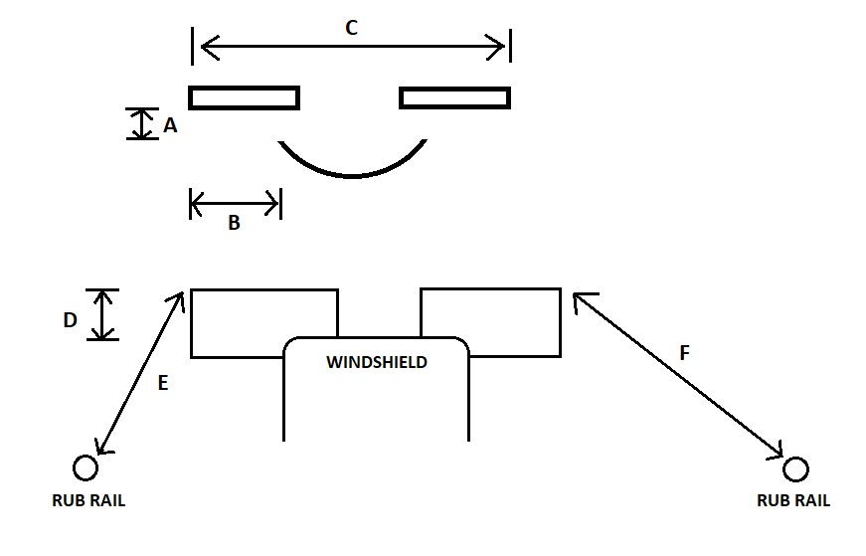

CONSOLE SIDE GRAPH MEASUREMENTS
WE HAVE THE WINDSHIELD CORNER LOCATED ON OUR PATTERN

- DISTANCE FROM THE OUTSIDE WINDSHIELD CORNER BACK TO THE GRAPH. (A)

- DISTANCE FROM THE WINDSHIELD CORNER OUT TO THE OUTSIDE EDGE OF THE GRAPH. (B)

- DISTANCE ABOVE THE TOP OF THE WINDSHIELD. (D)

- DISTANCE OF THE TOP OUTSIDE CORNER DOWN TO THE RUB RAIL. (E)
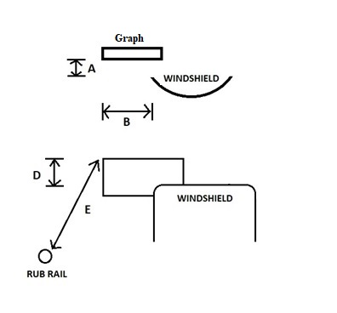

BOW GRAPHS MEASUREMENTS
- MEASUREMENT FROM NOSE OF THE BOAT OVER TROLL AND BACK TO TOP OF THE GRAPH. (A)
- MEASUREMENT FROM OUTSIDE TOP CORNER OF GRAPH TO THE RUBRAIL OF THE BOAT. (B)
- GRAPH HEIGHT FROM DECK TO TOP OF GRAPH.
- GRAPH WIDTH ( C )
- CENTERLINE MEASUREMENT FROM GRAPH TO WINDSHIELD ON DECK. (D)
- HEIGHT FROM DECK TO TOP CAP OF BOAT.
- MEASUREMENT FROM CENTERLINE OF BOAT TO CENTER OF GRAPH.

